ZHANGPU ZHONGLONG KENAF SEEDS CO.,LTD |  | Mobile: 0086-15695966658  Mobile: 0086 18959620286  TEL:0086 596 3215898  Email: cnkenafseed@gmail.com
Address: No.140, Dongsheng Road,Shuian town,Zhangpu County,Fujian province, China
Address in Chinese: 福建省漳浦县绥安镇东胜路 140 号

QUOTE OF THE HEMP ROLLER DECORTICATOR
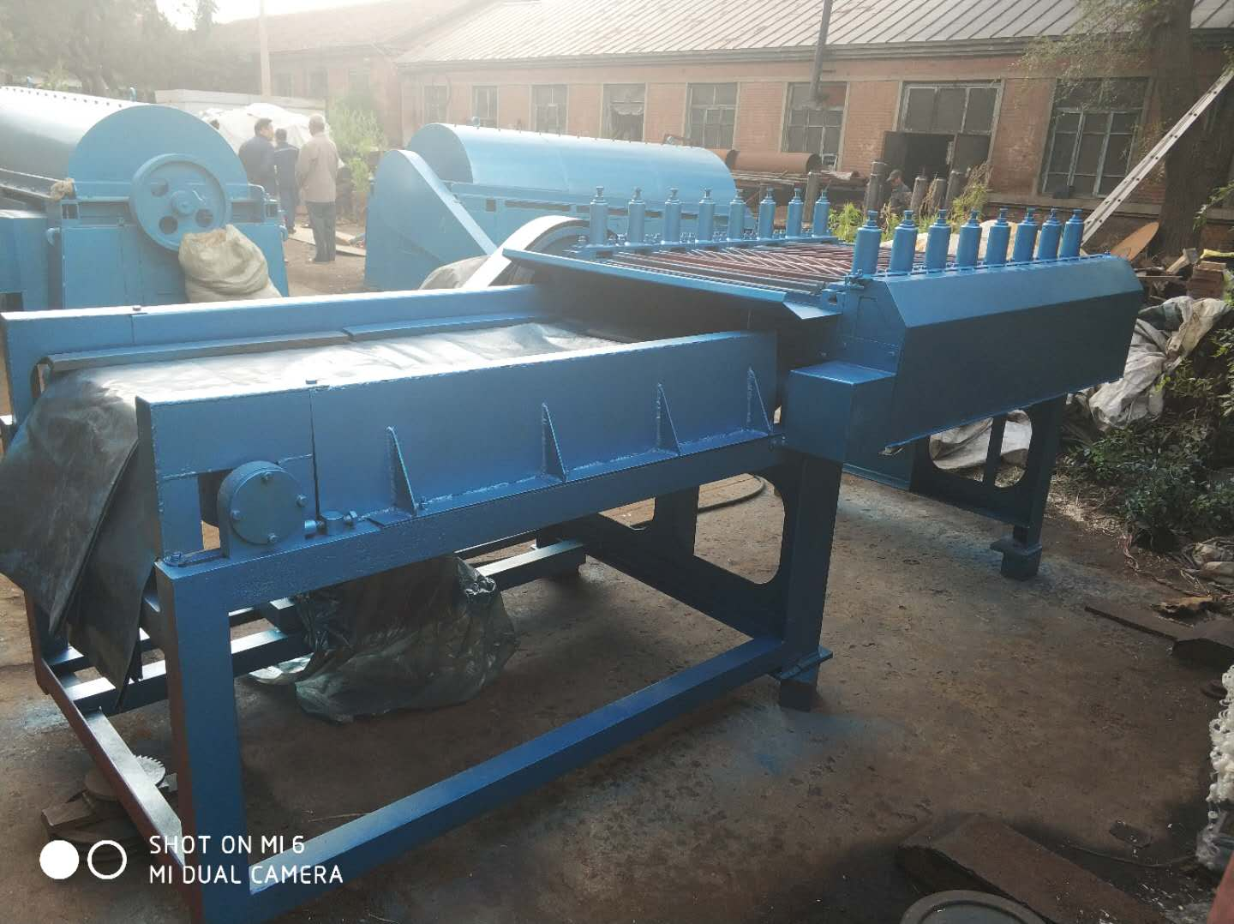 |  | Bank : CHINA CONSTRUCTION BANK CORP ZHANGZHOU BR.  A/C: ZHANGPU ZHONGLONG KENAF SEEDS CO.,LTD  A/C No. :35050166730700000014 SWIFT CODE：PCBCCNBJFJZ  Intermediary Bank: BANK OF AMERICA,NEW YORK(BOFAUS3N )  CHINA CONSTRUCTION BANK HONGKONG BR.(SWIFT :PCBCHKHH)  JP MORGAN CHASE BANK N.A.NEW  YORK(SWIFT:CHASUS33)
Name:. | Description |  | Quantity |  | Unit  price | Amount
Hemp Roller Decorticator | Size :2.7*1.2*1.25 M  Weight:3200 kilos  Packing:2010*1330*1440 mm wooden case and 1950*1470*1610 mm wooden case .  Production is 10 tons per 11 hours working .Pretty fast .  Each pieces is USD $ 7500with shipping freight to Italy Port Livorno  Production lead time 12 days.  Delivery lead time : 30-35 days. |  | Each 1 Unit |  | $8500 | $8500
Totally 3200 KILO | With Freight to Destination Port via Sea Freight
 |  |  |  | TOTAL |  | $8500

